Week 3-Day-1 -Assignment
Assignment-1 :
Generated Playwright-Typescript code for Leaf taps Login using Vibe coding:
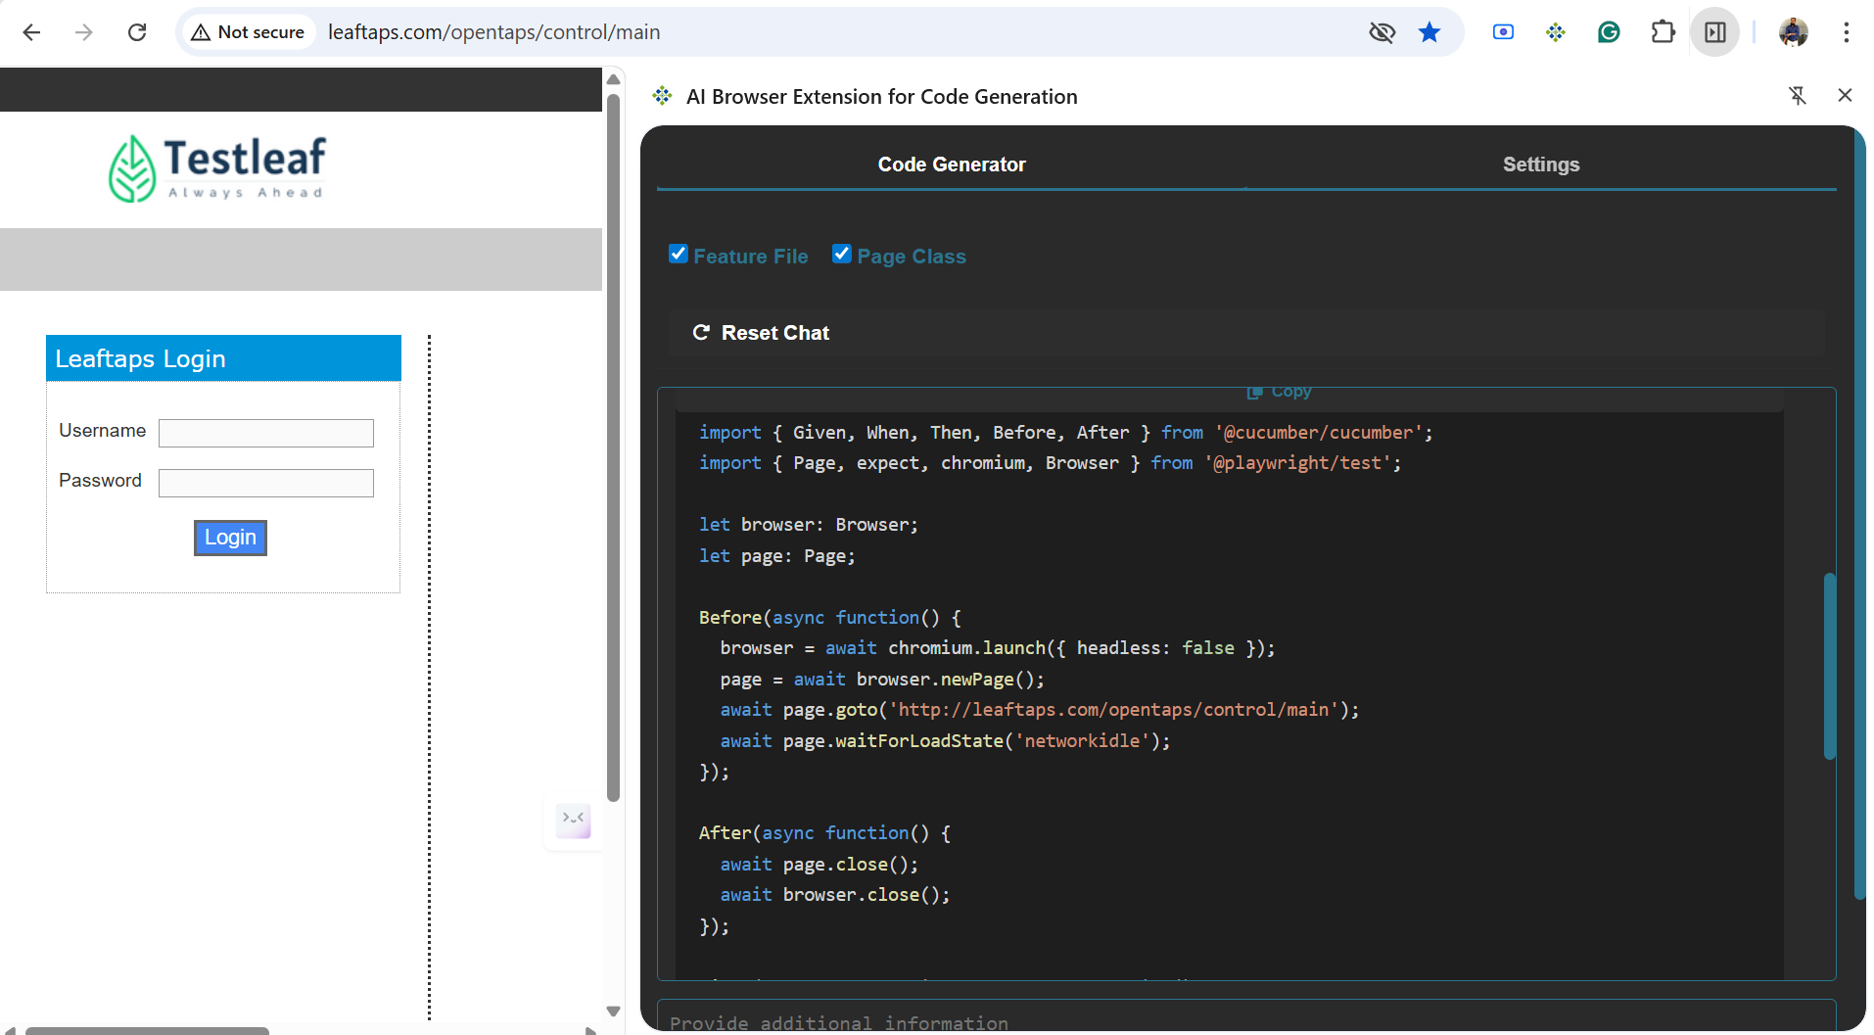
Feature: Login to Application
Scenario Outline: Successful login with valid credentials
Given I open the login page
When I type "<username>" into the Username field
And I type "<password>" into the Password field
And I click the Login button
Then I should be logged in successfully
Examples:
| username | password |
| "demouser" | "crmsfa" |
| "admin" | "admin123" |
| "RajeshKumar" | "Password1" |

import { Given, When, Then, Before, After } from '@cucumber/cucumber';
import { Page, expect, chromium, Browser } from '@playwright/test';

let browser: Browser;
let page: Page;

Before(async function() {
browser = await chromium.launch({ headless: false });
page = await browser.newPage();
await page.goto('http://leaftaps.com/opentaps/control/main');
await page.waitForLoadState('networkidle');
});

After(async function() {
await page.close();
await browser.close();
});

Given('I open the login page', async function() {
await page.goto('http://leaftaps.com/opentaps/control/main');
await page.waitForLoadState('networkidle');
});

When('I type {string} into the Username field', async function(username: string) {
await page.fill('#username', username);
});

When('I type {string} into the Password field', async function(password: string) {
await page.fill('#password', password);
});

When('I click the Login button', async function() {
await page.click('input[type="submit"]');
});
Then('I should be logged in successfully', async function() {
await page.waitForTimeout(2000);
const welcomeMessage = page.locator('#welcome_message');
await expect(welcomeMessage).toBeVisible();
});

Assignment 2:
Used the Bug magnet extension to fill
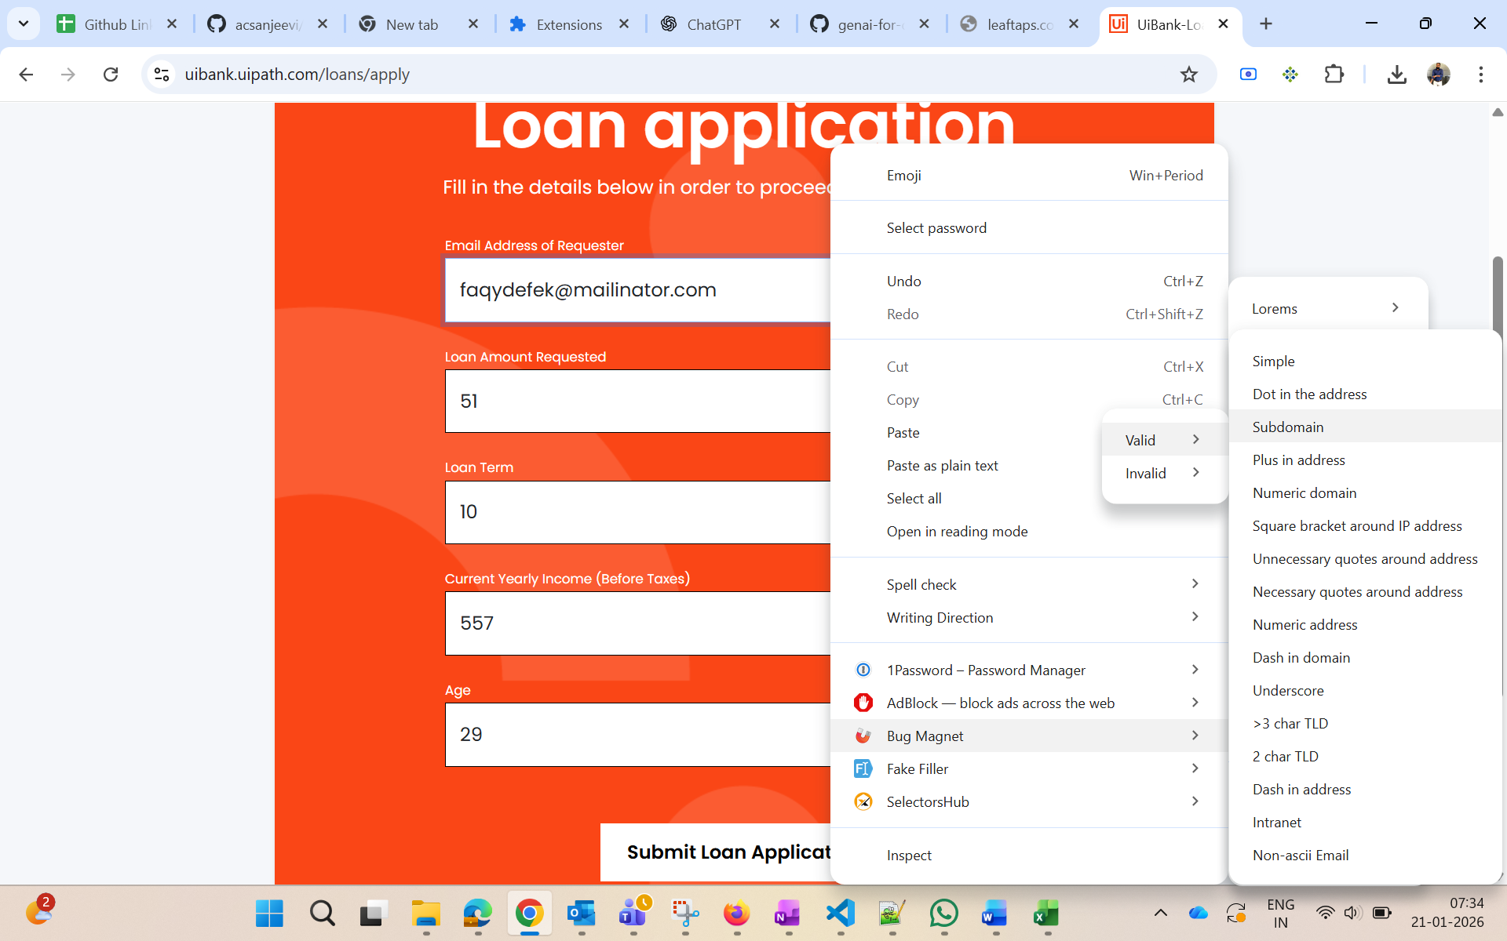
Assignment 3:
Grammarly
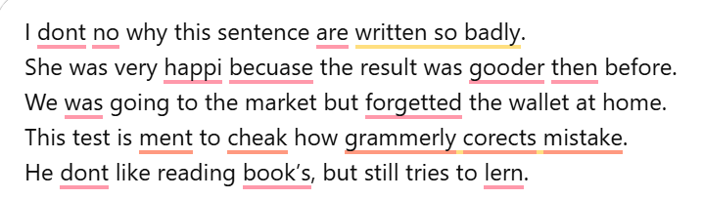
Corrected one
